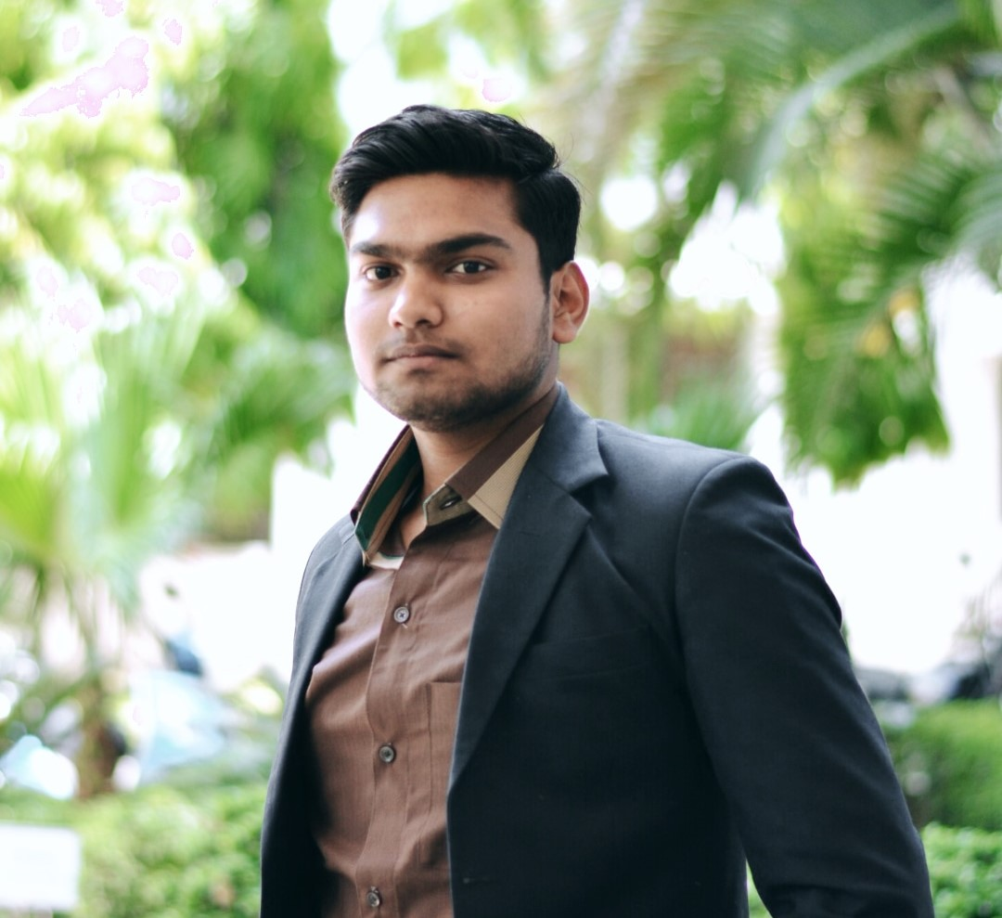

Kapil Namdev

Fresher

A hardworking and passionate job seeking to ﬁnd the opportunity to work in a fun and challenging working environment that will encourage me to improve and learn new and necessary skills as well as be motivated by the company to do best for the sake of helping myself and the company advance in the software engineering industry.

# Contact

**Address :-** Bhopal

**Phone :-** 9685955475

**E-mail:-** kapydev5@gmail.com

# Highlights

* Problem-Solving
* Active Listening
* Multitasking
* Self-motivated
* Calm under pressure

# Key Skills

* Python
* Django
* HTML
* CSS
* Bootstrap
* GitHub
* MySQL
* Basic of C and JavaScript

# Projects

**Blog Website**

* Making a Blog Website by using bootstrap and Python Django framework and module with the help of Jinja Templates.
* Create dynamic graphics to accompany blog posts.
* Posts on blog outlets to increase retention, acquisition rates and levels of engagement with blog.
* Creative post to write, edit, and create layouts for new articles and features

**Weather App**

* Making a weather application to search by city

Ro know the weather information.

* Learned new skills like API and applied to daily tasks to improve efficiency and productivity.

**Simple E-commerce Website**

* Making a simple E-commerce website with the help of HTML and CSS
* Learned and face the difficuilty of frontend web development problems

# Education

* **Bachelor of Engineering: Mechanical Engineering [2013-2017]**

Sagar Institute of Science & Technology, Bhopal

* **Higher Secondary School: P.C.M [2012-2013]**

Red Rose School, Bhopal

* **Higher School [2010-2011]**

Fr. Agnel Higher School Berasia,Bhopal